Complete the ‘Premium’ Experience at B Hotel Alabang
Get to taste the best of Filipino food and more at B Hotel Alabang’s Prime Café

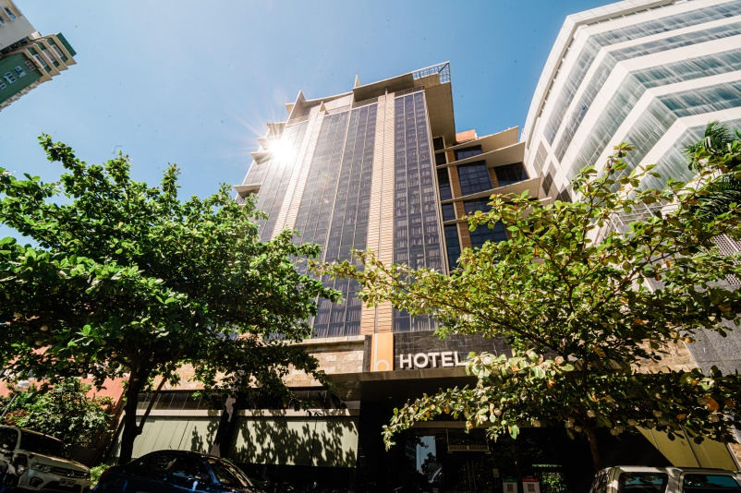

Manila, Philippines, August 2022 – Foodies need not look any further if they want to enjoy the best of Filipino food and more. B Hotel Alabang’s Prime Café offers the Philippines’ most sought-after dishes as well as other favorites from around the country.

This boutique hotel in Alabang may not be the largest in the area, but it is packed with everything you need in the city. A relaxing and homey accommodation, an outdoor Jacuzzi for ultimate relaxation, a gym, a function room that can accommodate up to 80 persons, a well-known Filipino restaurant, and a Pastry Corner for the best-baked concoctions in the Metro.

“We take pride in providing good quality of service. Being the number 1 TripAdvisor hotel in the Alabang area is an honor for us, and I believe that this achievement is proof of the quality of hospitality that we have always strived to provide our guests,” said Ms. Glennis Narciso, Hotel Manager of B Hotel Alabang.

One aspect of their service that they are highlighting is their very own restaurant – Prime Café. This restaurant offers an impressively wide variety dishes and of particular note is the top-notch Filipino cuisine that it is known for. Their chefs headed by Sous Chef Andrea Urcia put their heart into every dish that they serve, especially the ones that boast rich flavors.
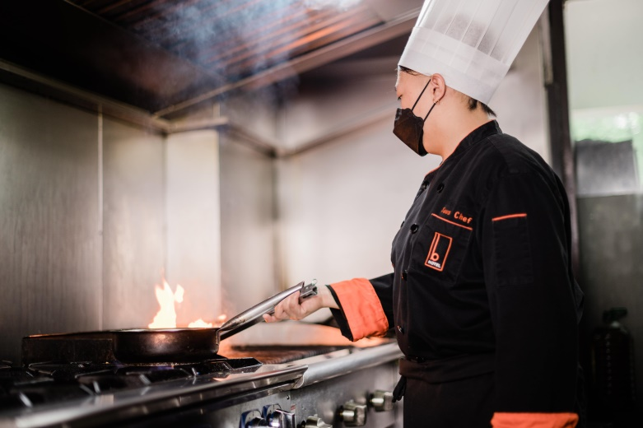

Prime Café offers buffets and Bistro a la carte and is open daily from 7:00 am to 10:00 pm. Lunch buffets are scheduled every Friday from 11:30 am to 2:00 pm and cost only Php 750 per person. They also offer breakfast buffets every weekend from 6:00 am to 10:00 am which only costs Php 650 per person.

And even if you are in the North area, you may still get to taste the best Filipino and also international cuisine at B Hotel in Quezon City headed by Executive Sous Chef Vincent Odejar. The Lobby Café in B Hotel Quezon City is known for specializing in international cuisine that will surely give you a delicious journey for your taste buds. Serving ala-carte dishes and buffet breakfasts, the Lobby Café is also a feast for the eyes as it is to the tummy. It has also a cool vibe that perfectly matches the hotel’s industrial architecture.

B Hotel Alabang and B Hotel Quezon City are 4-star hotels that are both managed by The Bellevue Hotels & Resorts. If you are looking for great amenities and exceptional service at a price that won’t break the bank, these hotels are definitely your best choices.

For inquiries and reservations, you may contact B Hotel Alabang at (+632) 8828 8181 or visit www.bhotelalabang.com, and B Hotel Quezon City at (+632) 8990 5000 or visit www.bhotelqc.com.

